**JAC444 - Lecture 13**

JavaFX

Segment 2- GUI

JavaFX Programming

**In this lesson you will be learning about:**

### • History of GUI in Java

### • Principles of using JavaFX

### • JavaFX as library of JDK 8

# New Technologies for GUI

* Java is an evolving language together with its microsystem
* GUI programming requires use of all the basic knowledge and Java concepts before one could start doing GUI
* JavaFX is a new framework for developing Java GUI applications

# History of GUI in Java

Java GUI History:

* Old GUI Framework: AWT (Abstract Window Toolkit)
* Until Java 7: Swing - many current applications use it
* Java 8 and later: JavaFX

# JavaFX Look & Feel

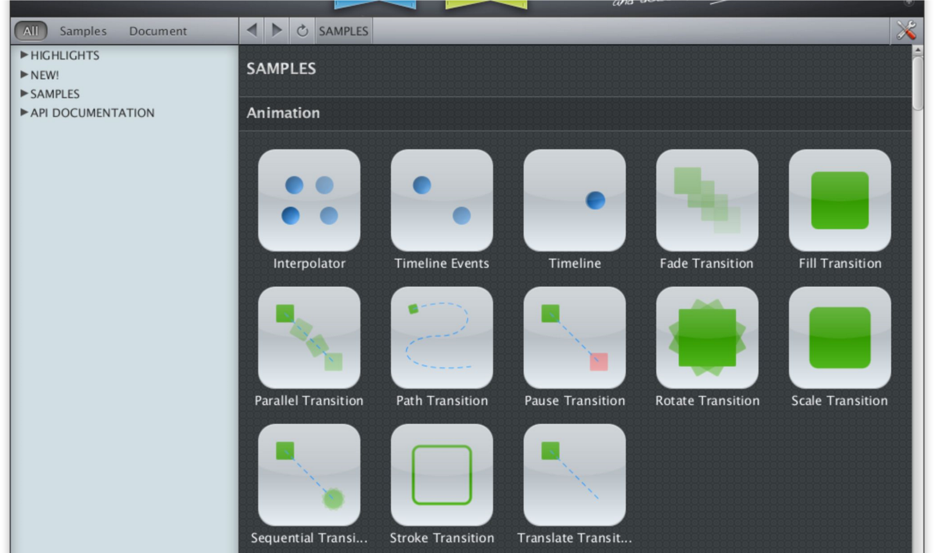

5

# JavaFX - HelloWorld

**public class HelloWorld extends Application { public static void main(String[] args) { launch(args); }**

// Override the start method in the Application class **@Override public void start(Stage stage) {**

**// Create a scene with a button in it**

**Button bOK = new Button("OK"); Scene scene = new Scene(bOK, 150, 300); stage.setTitle("Example JavaFX");** // set the stage title **stage.setScene(scene);** // place the scene **stage.show();**

**}**

**6**

# Concepts

* **Stage**

Represents windows, top level container

Setter and getter methods: setTitle(), setWidth()

* **Scene**

Each stage has a scene

Scene holds GUI controls such as buttons, lists, etc

* **Pane**

Panes for better layout design and presentation

**Jordan Anastasiade – Java Programming Language Course**

# Actions as Lambda Expression

//Lambda Expression

onAction ((ActionEvent e) -> {

element.displayFromStart();

})

//Lambda Expression with parameter type inferred

## onAction (e -> element.displayFromStart();)

**Jordan Anastasiade – Java Programming Language Course** 8

# JavaFX Structure

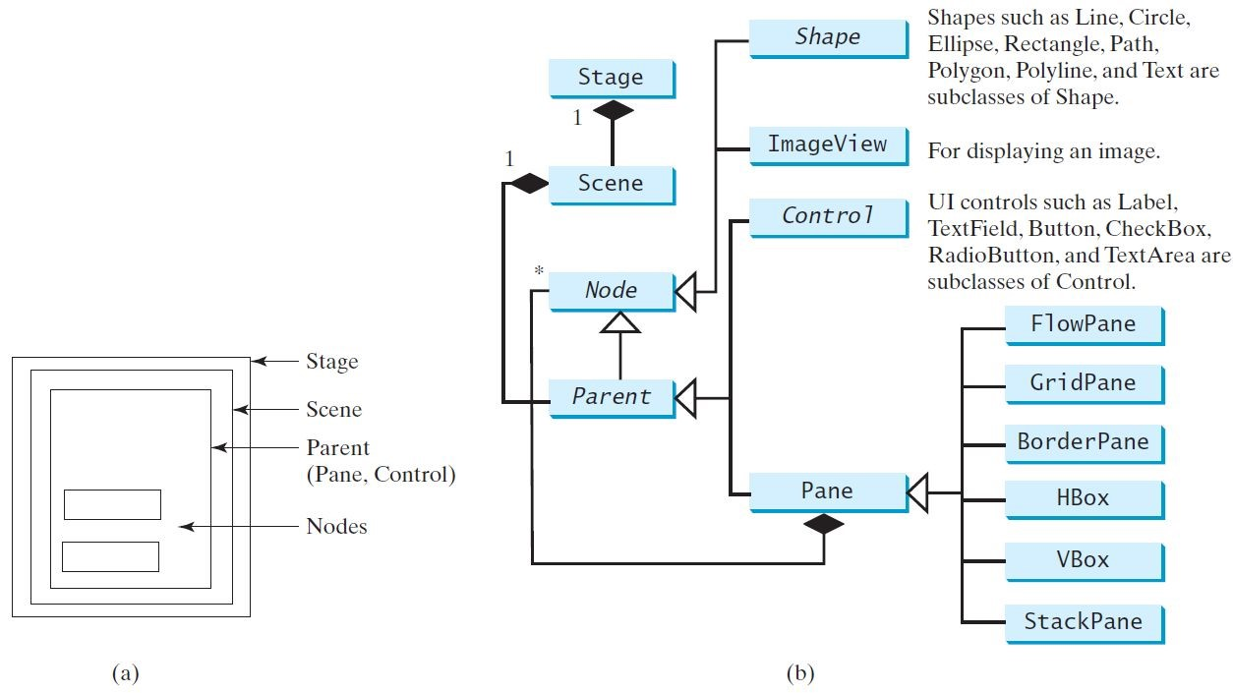

http://docs.oracle.com/javafx/2/scenegraph/jfxpub-scenegraph.pdf

# JavaFX or Swing

JavaFX Advantages:

1. GUIs are created a lot faster than in Swing and AWT
2. Easy integration of sounds, images and videos and of web content
3. Code is simplified in JavaFX by strict MVC Architecture
4. JavaFX can be integrated in Swing applications, allowing for a smoother transition

**Jordan Anastasiade – Java Programming Language Course** 10

# Conclusion

**After completion of this lesson you should know:**

### • History of GUI programming in Java

### • Principles of programming in JavaFX

**Jordan Anastasiade – Java Programming Language Course**